FLiP [Financial Literacy Program]

FLiP is a program that is designed to increase financial awareness in youth served at the Boys & Girls Clubs. Many of those youth are from low-income families and this program aims to impact their future by breaking the cycle of poverty and living pay check to pay check by exposing them to financial terms, concepts, and strategies at an impressionable age.

FLiP is made up of several pieces, including curriculum both nationally and locally developed, field trips, family services and interactive activities.

Programs will run Money Matters: Make it Count, a Boys & Girls Clubs of America program. The program will be run over the course of 10 days. The lesson plans to be conducted from the curriculum are specified in this handbook. There are three versions of Money Matters to be facilitated, the original curriculum, which is written for youth in middle school or early high school, Money Matters Jr., developed locally with upper elementary school students in mind and Fast Pitch, also created locally to serve teens. During Money Matters, There are two field trips to be organized by each individual program. One field trip is to a local bank, and the second field trip is to a local college or university.

There will be one other component making up the entirety of the FLiP program which will bring families together to learn the benefits and practices of responsible financial planning.

That component will be a finance presentation, aimed at capping off a year filled with beneficial lessons regarding money, credit and financial security. The finance presentation could include anything pertaining to financial information that families can benefit from. Local banks have been known to created and facilitate a presentation on saving, saving for college, budget basics, among many other topics. American Express employees have conducted Reality Town scenarios for kids. University/college employees have done presentations about financial aid for families as well. The possibilities here are immense.

The required components to complete FLiP are as follows:

  - Money Matters: Make it Count (one of three versions)
  - Bank Field Trip
  - College/University Field Trip
  - Finance Presentation

To conclude the year and all of the accomplishments of the youth, their parents and the programs, there will be a FLiP recognition ceremony, with all of the sponsors and participating youth in attendance, in early May.

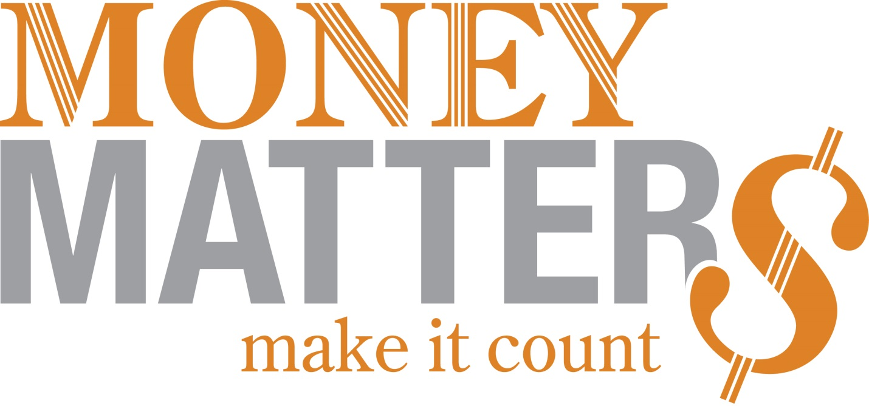

Money Matters: Make it Count is a 10 day program and includes 2 field trips
Day 1: FLiP Introduction
- Take attendance at the beginning of the activity each day.
- Conduct the following activity to introduce them to money:
  - On pieces of papers, write money amounts from $1 to $10,000 fold it and place it in a bag or bowl. Then have the students pick the paper out of the bowl and then ask them what they would do with it.
- Conduct the Pre-Test (Appendix p2).
- Go over the program layout and talk about field trips. Go over what is required and expected of them during the program.
- Conduct one of the following activities:
  - Word Search (Appendix p7)
  - Crossword (Appendix p8)
Day 2: Money Matters Unit 1 - Spending Wisely
- Discuss Budgets.
- Discuss Needs vs. Wants.
- Conduct one of the following activities:
  - Money Matters: Make it Count “Budget Basics” (Appendix p10)
  - What do You Want: Activity 1C (p11 Money Matters Facilitator’s Guide)

Day 3: Money Matters Unit 2 - Saving and Investing
- Discuss Saving and Investing.
- Conduct one of the following activities:
  - Money Matters: Make it Count “Savings basketball: Give it Your Best Shot” (Appendix p13)
  - Money Matters: Make it Count “Banking and Saving Questions and Answers” (Appendix p15)
Day 4: Field Trip to the Bank
- Check out a Club vehicle if necessary and be sure to arrange the field trip with a bank prior to going. Take Pictures.
- Refer to the Bank List (Appendix p19).
Day 5: Money Matters Unit 2 – Financial Goals
- Discuss Goals and Finances.
- Discuss Financial Goals.
- Conduct the following activity.
  - Money Matters: Make it Count “Financial Goal Setting: Window to Success” (Appendix p16)
Day 6: Money Matters Unit 3 – Planning for College
- Discuss College as an investment.
- Conduct the following activity.
  - Personal Inventory (p29 Money Matters Teen Personal Finance Guide)

Day 7: Field Trip to College
- Check out a Club vehicle if necessary and be sure to arrange the field trip with an institution prior to going. Take Pictures.
- Refer to the College List (Appendix, p20).
Day 8: Money Matters Unit 5 – Being your own Boss
- Discuss business ownership.
- Conduct the following activity:
  - Create a Business (Appendix p22)
Day 9: Money Matters Conclusion
- Review everything they have learned.
- Conduct and record the Post-Test (Appendix p2).
- Conduct the FLiP Survey (Appendix p6).
Day 10: Celebration!
- Have a party with money games, food and prizes!
- Take Pictures.

Additional Resources:
- Crossword Puzzles http://www.crosswordpuzzlegames.com/create.html
- Quizzes http://www.themint.org/kids/the-truth-about-millionaires.html
- Quizzes http://www.themint.org/teens/i-paid-how-much.html
- handsonbanking.org
- practicalmoneyskills.com
- thirteen.org/finance/games
- http://pbskids.org/itsmylife/games/boss/
- http://www.teachingkidsbusiness.com/how-to-start-your-own-business.htm
- http://www.pbs.org/teachers/thismonth/business/index1.html
- http://www.yeskidzcan.com/files/SocEntWorkbookJune15.pdf
- http://www.allterrainbrain.org/PDFs/ATBActivityGuide.pdf

